# Image Processing using OpenCV

## Contrasting methods:

Used below are, CLAHE, Gamma Corrected image, Histogram equalisation

* Original Image

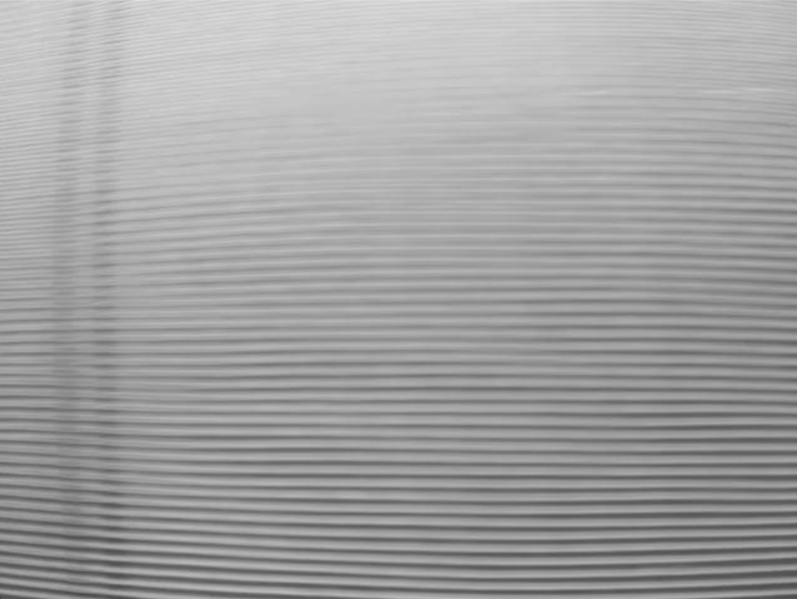

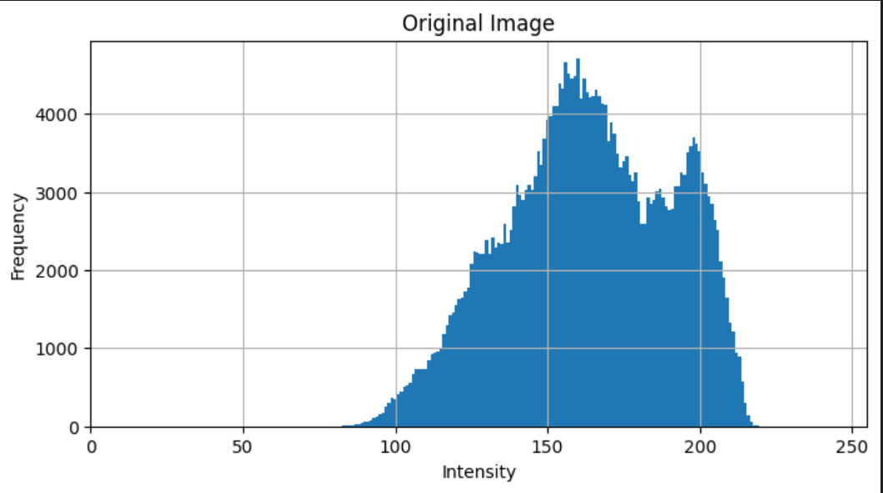

* CLAHE

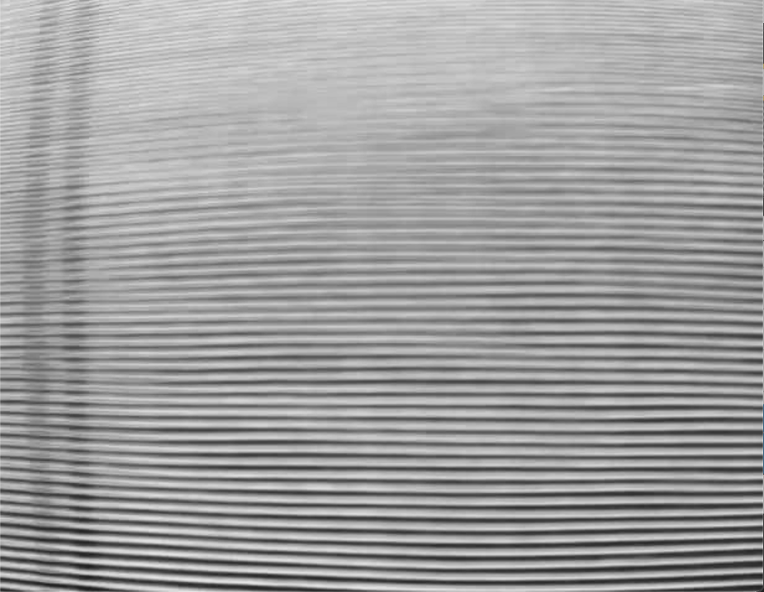

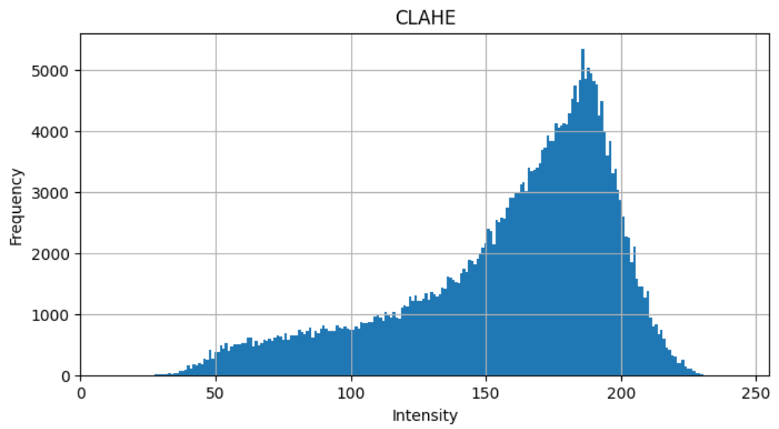

* Gamma Corrected:

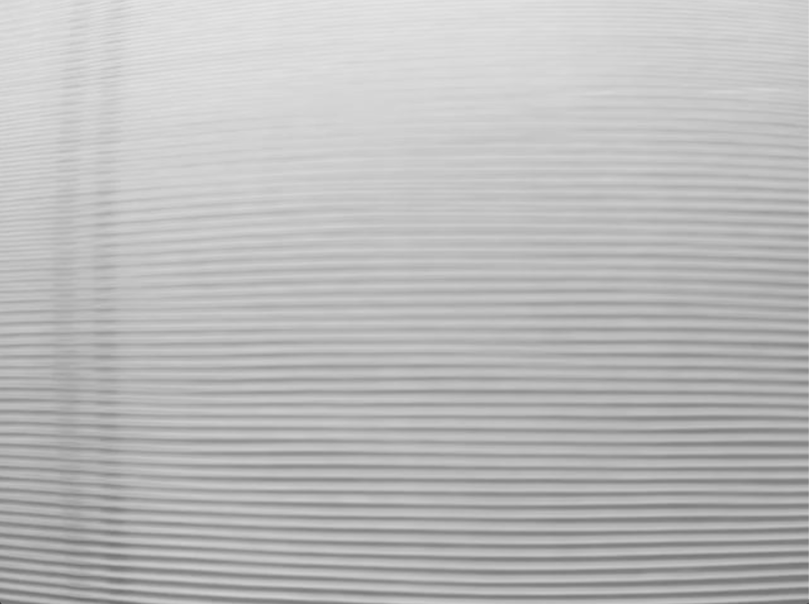

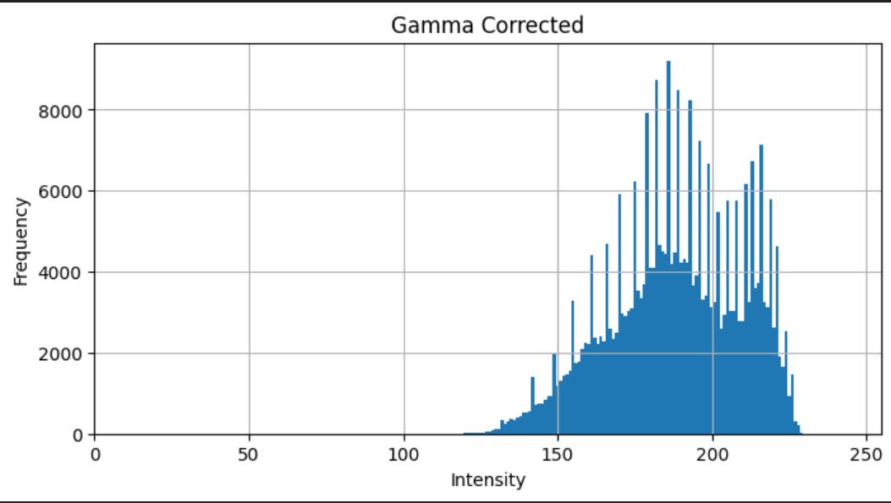

* Histogram equalization:

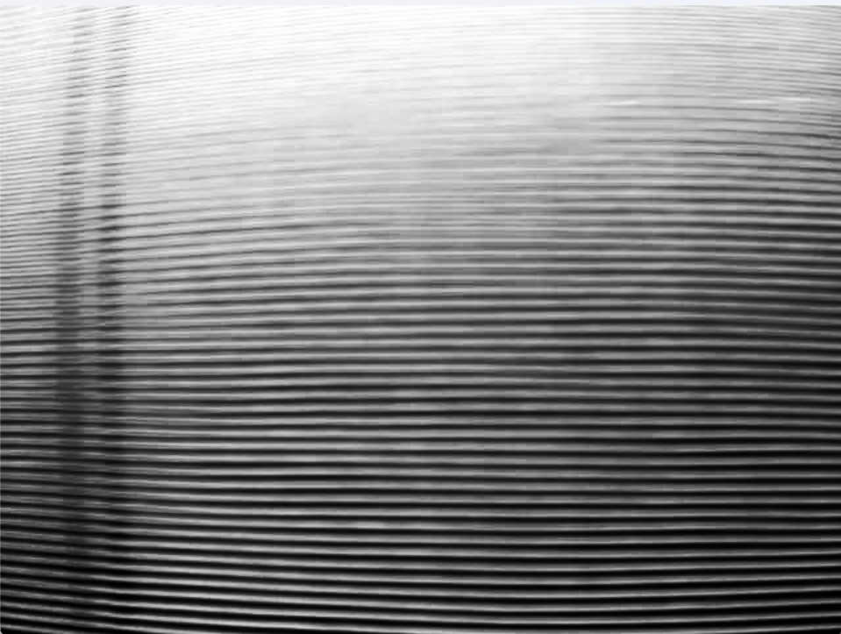

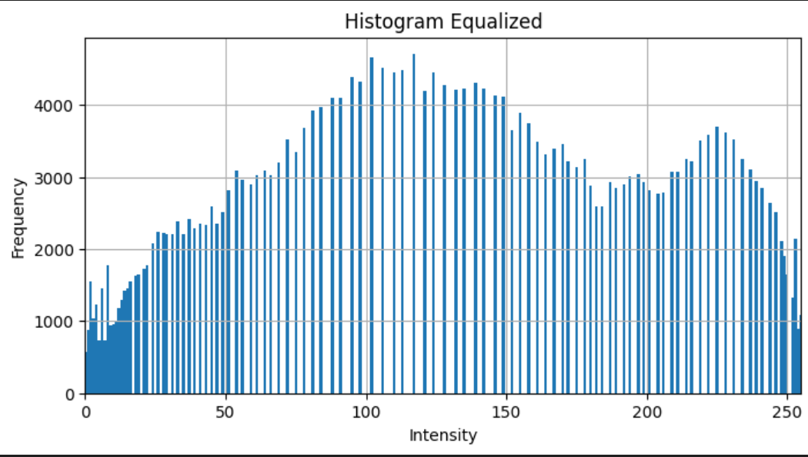

Out of the contrasting techniques above, we see **CLAHE** being the only technique that is effective because:

* **Gamma corrected** doesn’t work as it pushes all pixels into higher intensity values.
* And **histogram equalization** is not preferred by us, as it has no parameters to work with and manipulate the extent to which the contrasting be done.

So, moving forward only CLAHE is taken for experimentation.

## Blurring (7,7):

Before moving forward to the contrasting results, given the nature of the fabric, we would also want to change homogenise the ‘dark strips’ a bit more. This can be done by blurring which will also turn to blur out the noise/brightness irregularities in the image. This would help later on in contrasting as well which would tend to highlight these irregularities.

The resulting image is:

* Original Image



* Blurring:

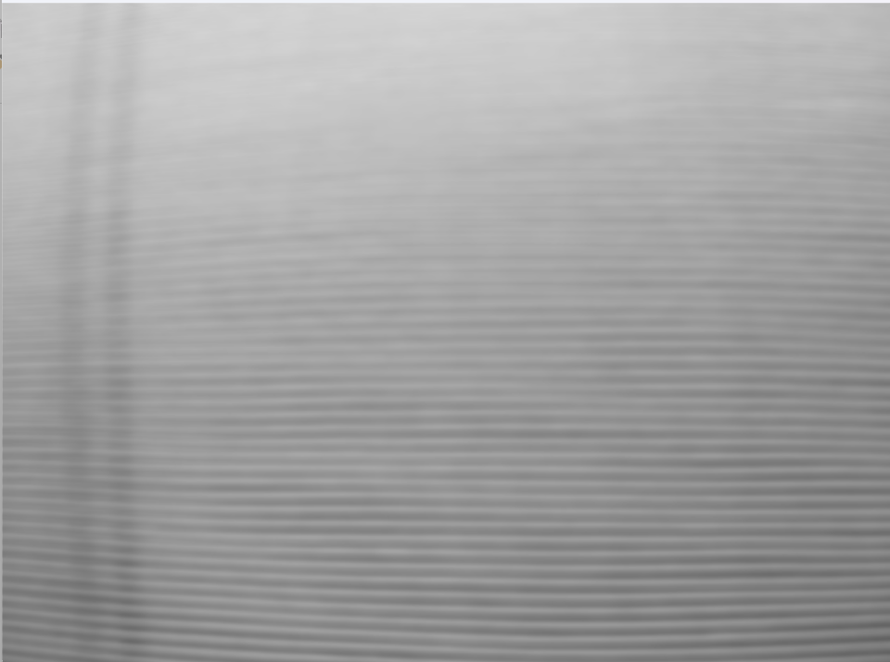

## Using CLAHE moving forward:

Here, we will use multiple parameters to check which one works best. The idea is to get the most contrast out of the image but also to not let too much noise get highlighted, given the varied luminous nature of the image dataset.

The standard is to use the clip_limit as 1.5 to 2.5 but we will just show difference in increasing and decreasing the limit:

* CLAHE (clip_limit = 2.0)

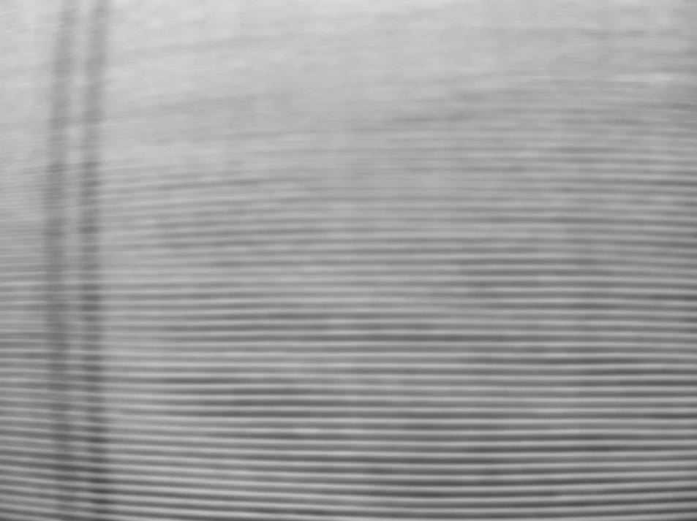

* CLAHE (clip_limit = 4.0)

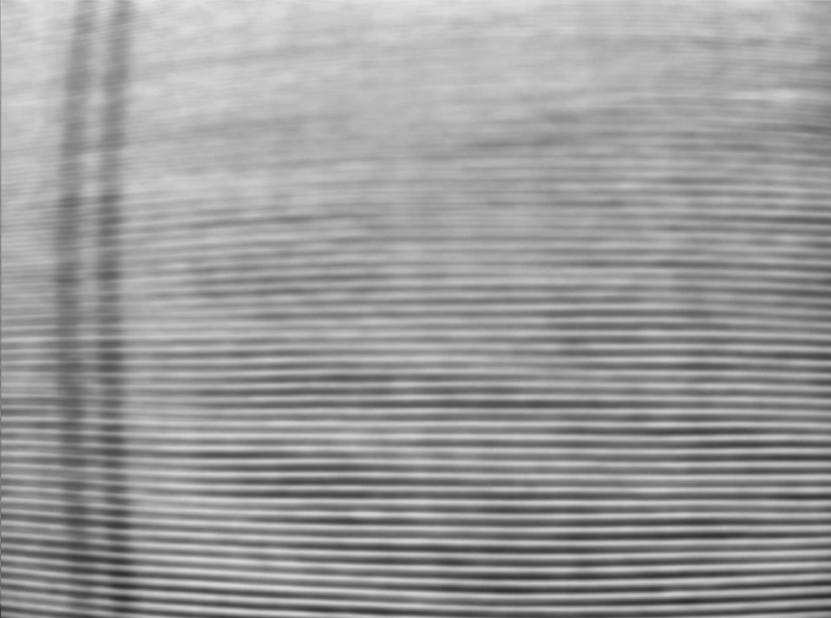

The above images show, while we increase the clip_limit the minor defect seems to be highlighted more. But it happens at the cost of highlighting some noise in the rest of the image as well, and we will see later on that it hurts the final image.

Going forward, we will use the clip_limit = 3 to move forward and will later and change it to get the best results.

## Using Scharr as the edge detection technique:

The kernel used for this is:

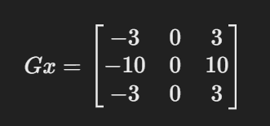

Notice that we are using Gx only and not Gy, the reason for this is, we do not want changes in the y-direction, we only want changes in the x-direction to get the gradient values highlighted for the ‘dark strips’.

The reason for using Scharr as opposed to something like Sobel is due to the values of Sobel matrix:

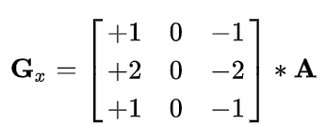

And the image produced is:

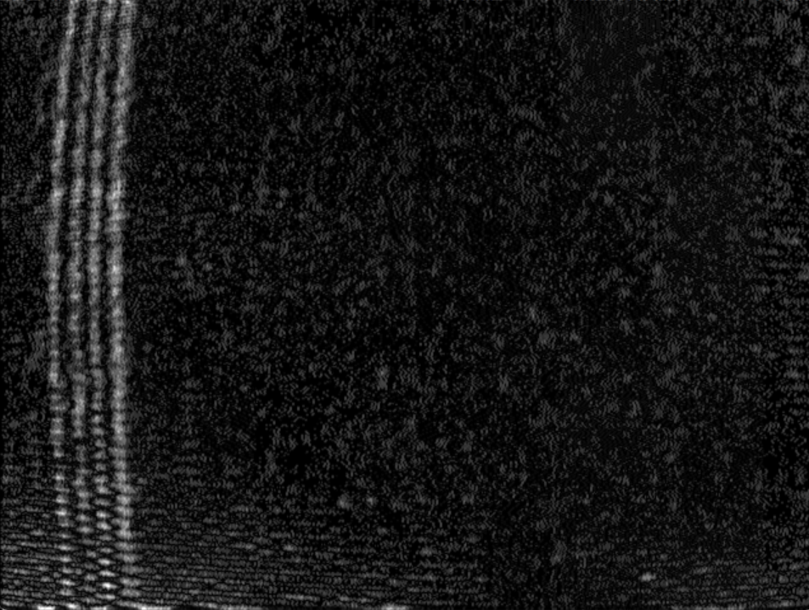

## Blurring again (9,9):

This is used again because as we can see we get the ‘bright strips’ which are slightly discontinuous. To make the continuous and to make the noise die out a bit, we blur this result.

The resulting image is:

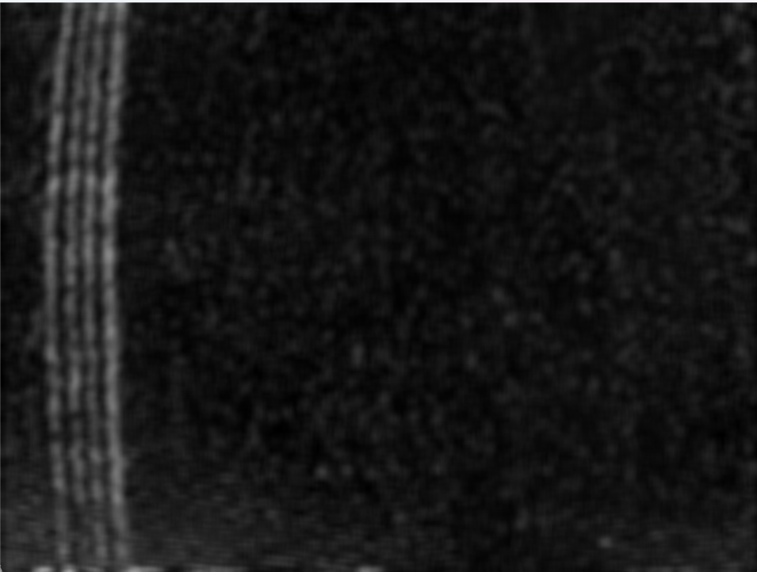

## Masking and thresholding:

We come to the final step of this process where we wish to completely eliminate the noise and highlight the ‘bright strips’ using binary thresholding.

We have set the masking limit at 50 (i.e. removing all pixels with the intensity value below 50) and set pixels above 50 to 200, creating an almost black and white image.

The resulting image that we see is:

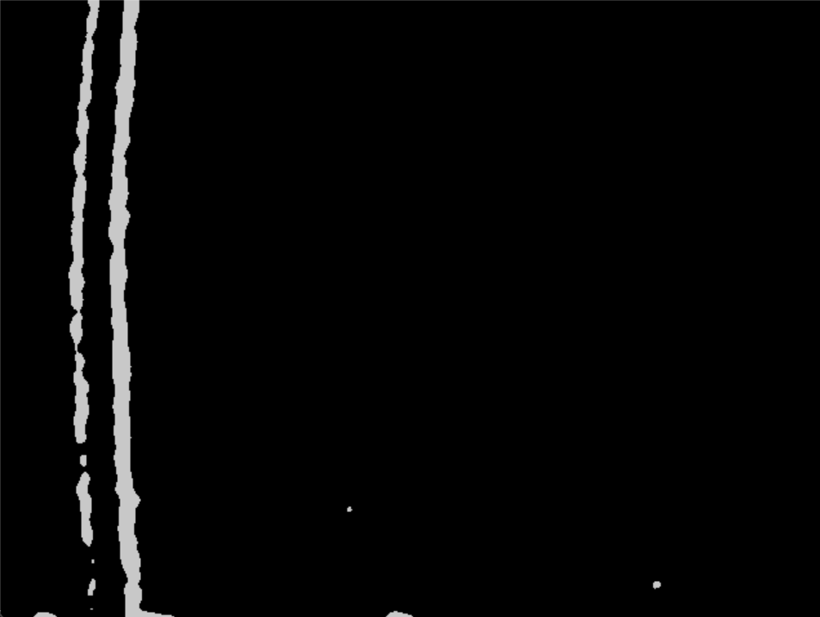

The slight difference in the previous two images is because of the order of the use of the function *convertScaleAbs.*

While this process with the given parameters does well in generating clean results for high contrasty images, it does not do so well in faint images. This is where we will change parameters like clip_limit and changing the default kernel to get the best results even in faint images.

Before we move on, the worst resulting image is:

* Original image:

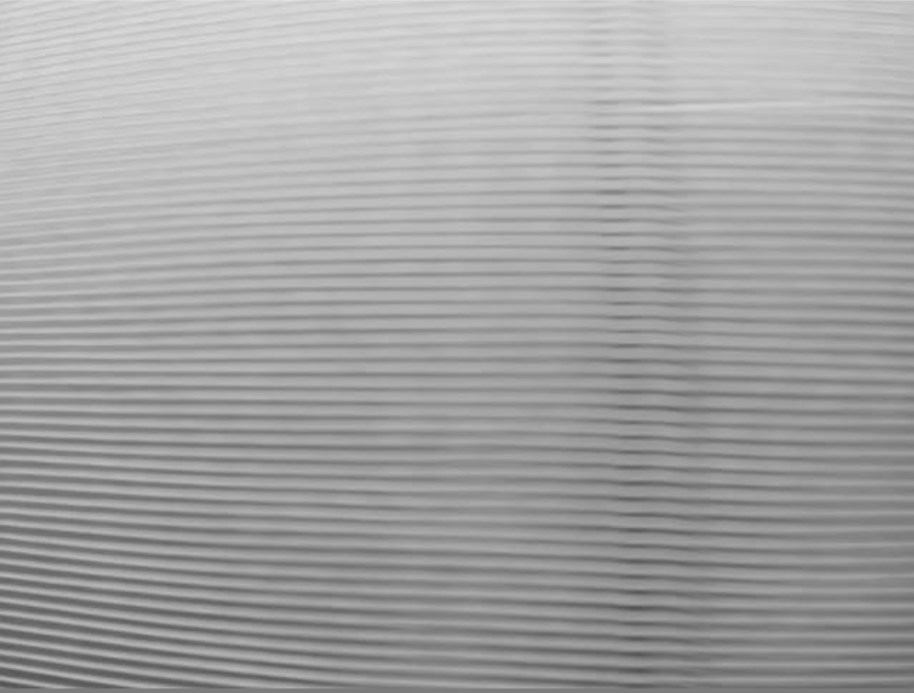

* Resulting image:

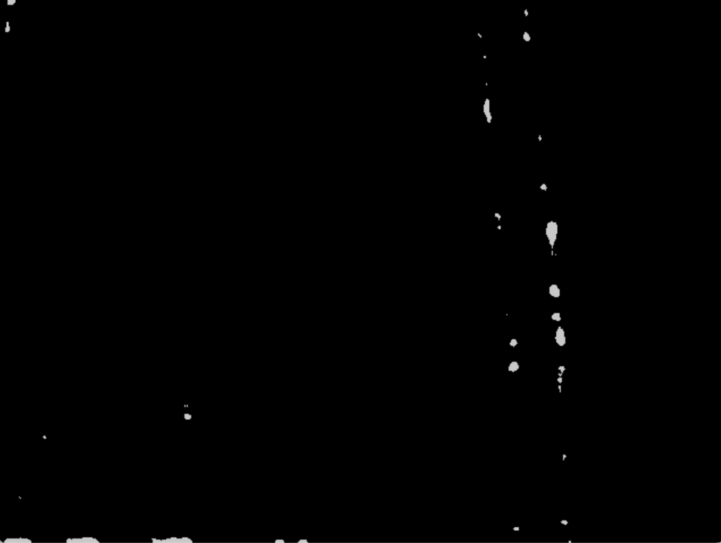

## Changing a few parameters:

Note that, changing the parameters here would increase the noise in the images where there was clear distinction of the ‘bright strips’.

### Changing the default Scharr kernel a bit:

We are changing multiple things at once to get the best results:

1. The default kernel to:

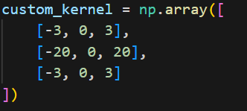

1. Changing the second blur size kernel to (13,13) from (9,9).
2. Changing the clip_limit in CLAHE to 5.

The resulting image is:

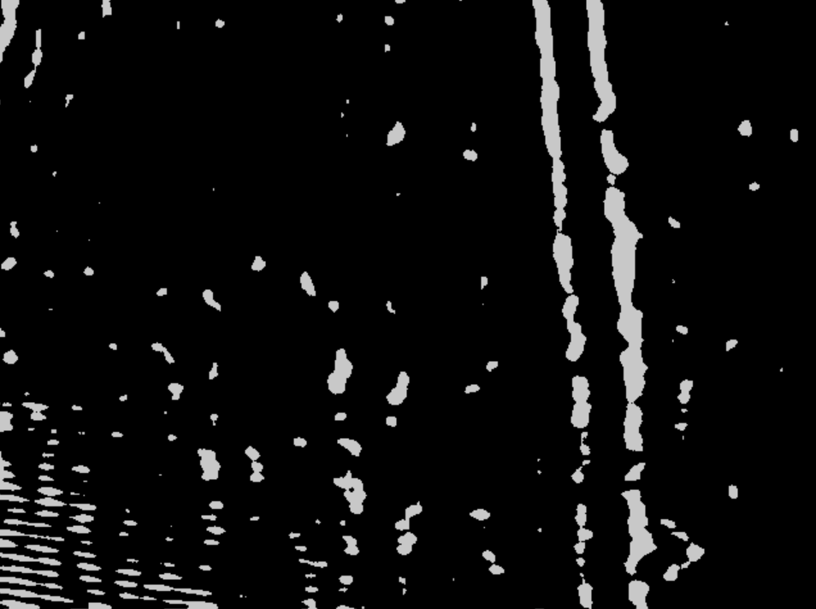

However doing this, results in the noise being captured as well in the ‘clear’ images as well. For example, our stock example in this document changes to this:

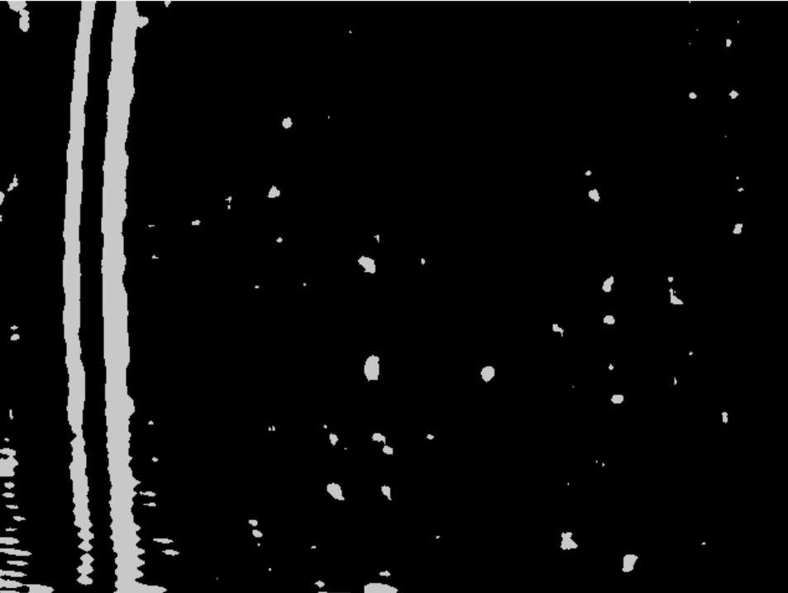

All these tweaks highly depend on how much tolerance for noise is there in the software to predict defects accurately.

## Using Morphological operations on the binary images:

Now, we move on to clean up the noise a bit. We do that by performing opening and closing operations on these images. The result that we get is quite promising.

Original Image:

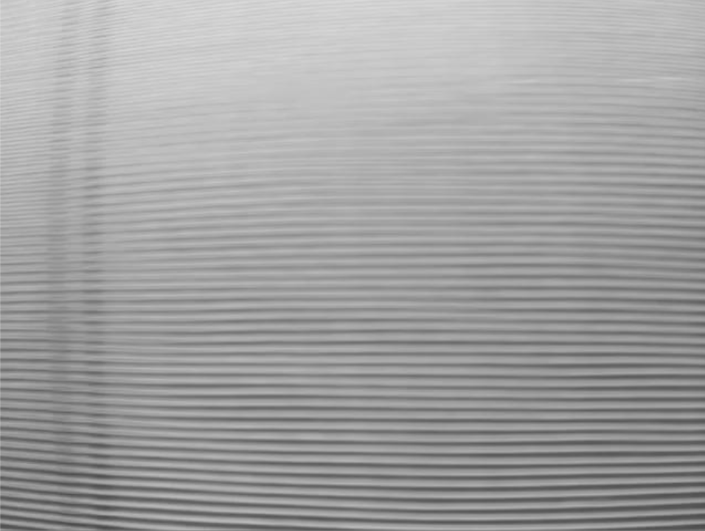

After Scharr and thresholding:

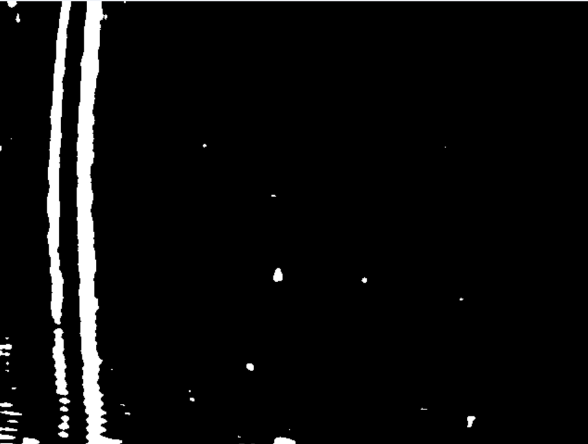

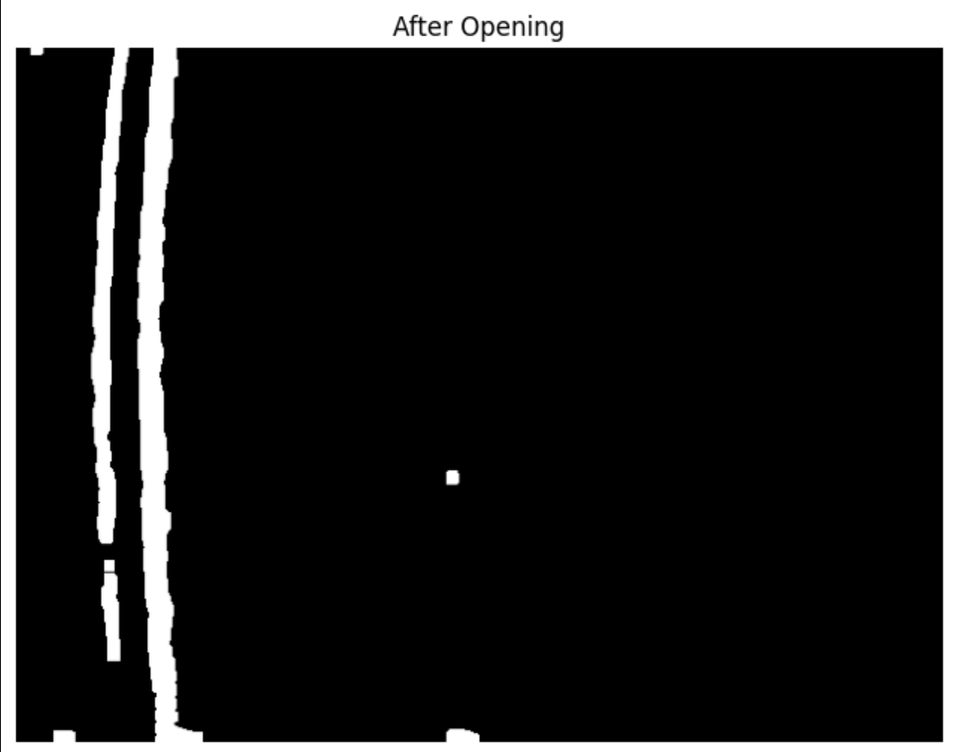

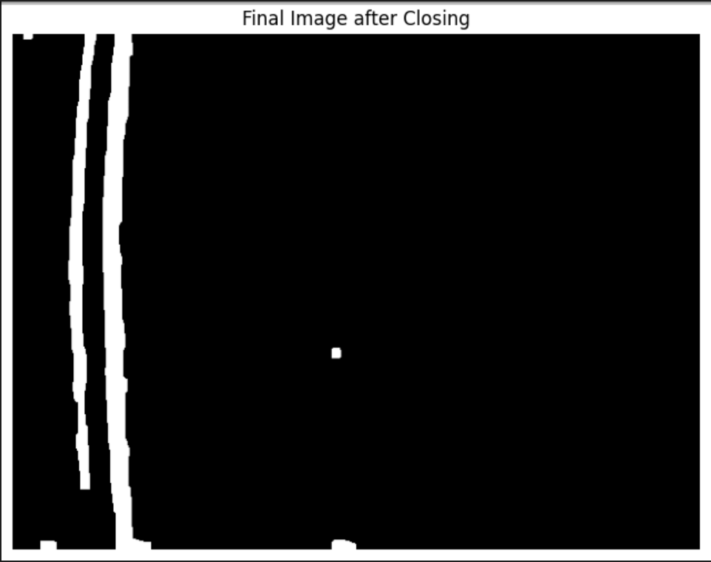

So, for understanding purposes, Opening means erosion followed by dilation and Closing means the other way around.

Opening is done to remove small objects while retaining big objects, and closing is done to clump/highlight the big objects.

For experimentation purposes, let’s see how this fairs against fainter images.

Original image:

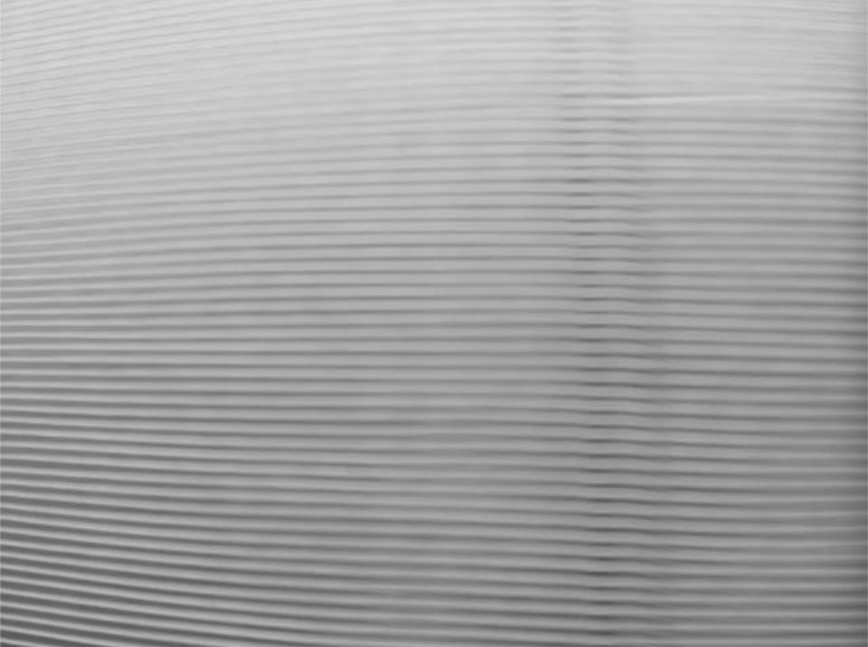

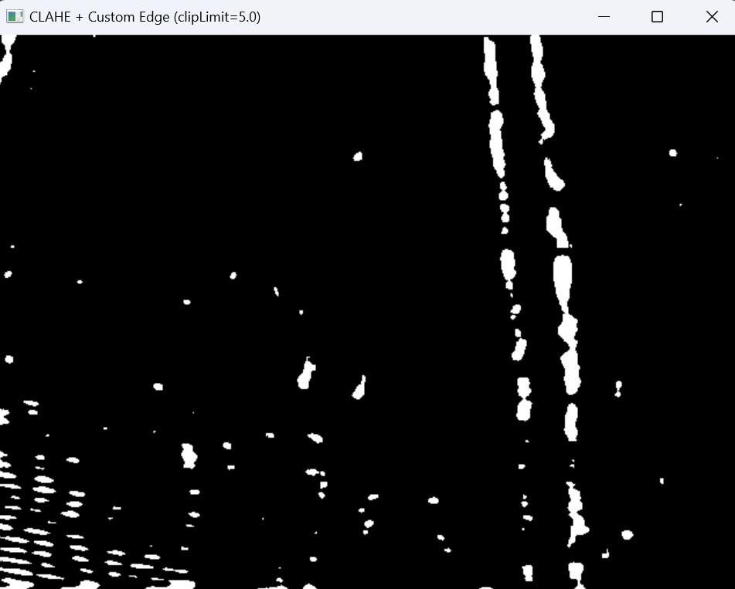

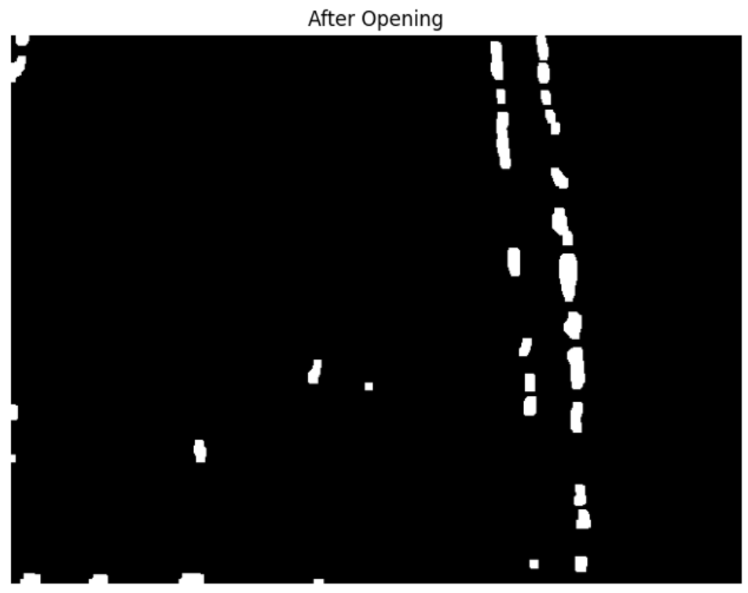

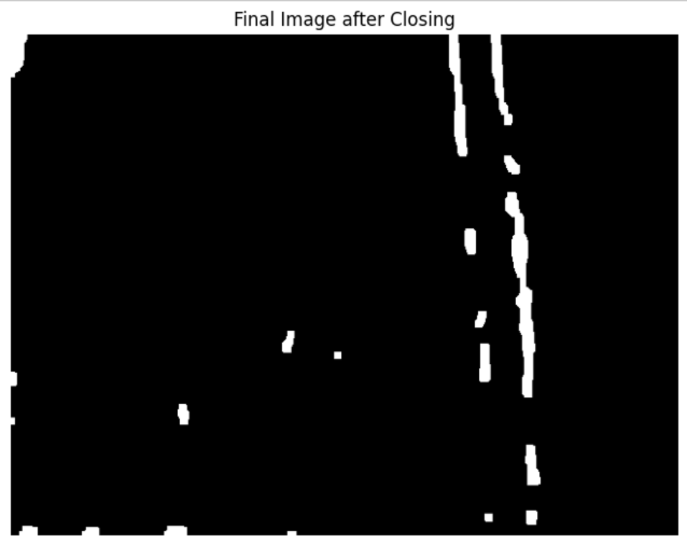

## Using contours to classify these images:

We will draw contours on this image, and take particularly **closed contours** to detect faults. We notice upon experimentation that there are two methods to use contours to detect faults in the fabric. The idea is to use either the length of the contours or the area of them and find the ‘optimal’ number that satisfies most images in a given class.

Upon checking all the largest contours, we find that the maximum contour length of any faulty image is around **390 pixels (+- 10 pixels)**.

And, as for the area, the maximum area of any faulty image is around **2300 pixels**. The idea here is to find the best method then to find fault.

What we see is that there are two faulty detections in the ‘contour length model’. Whereas, the lowest we can go in using area is 3. We notice that an image can have a lengthy contour but can have slightly narrower shape of it, resulting in a contour which does not have a big enough area to meet the threshold.

Example:

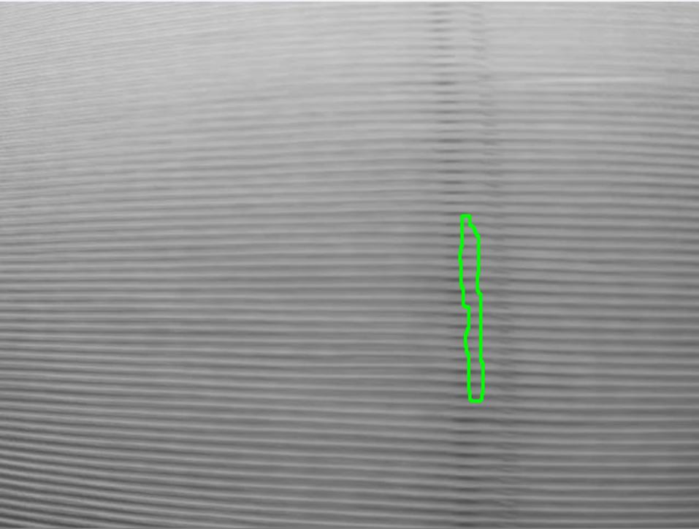

This particular image above, can be detected as a fault using the contour length method. We observe that there are **less outliers** in the contour length method.

Now, let’s move on to an error that this has surprisingly failed to identify. The issue lies in the bad default folder. So, for this particular image below, we see that the contour isn’t big enough to either pass the area or the contour length test.

The good news is that it does work in principle, for a very similar image shown further below.

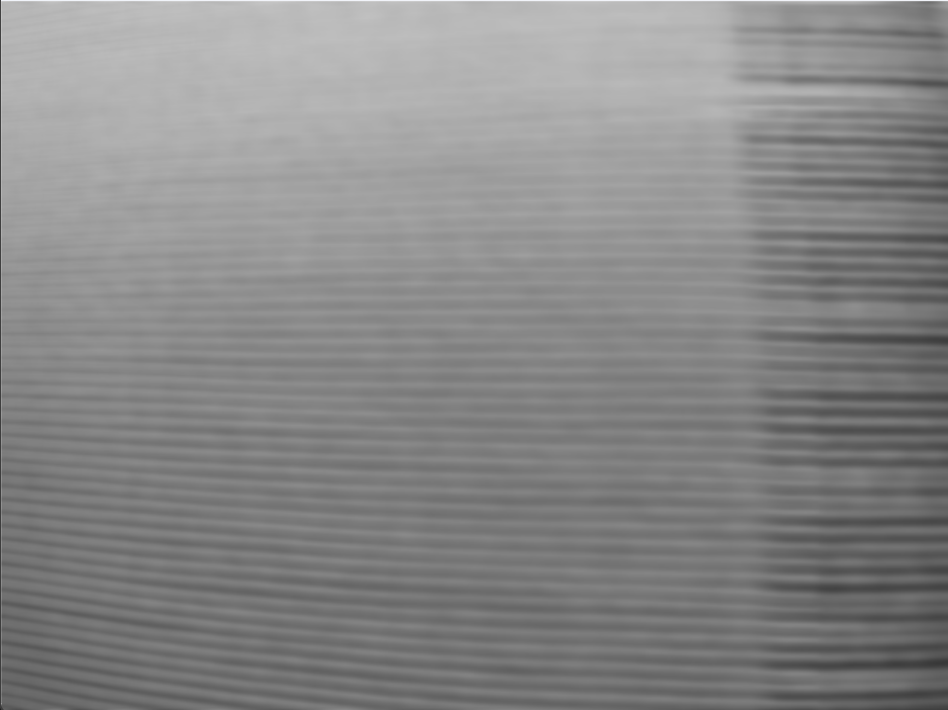

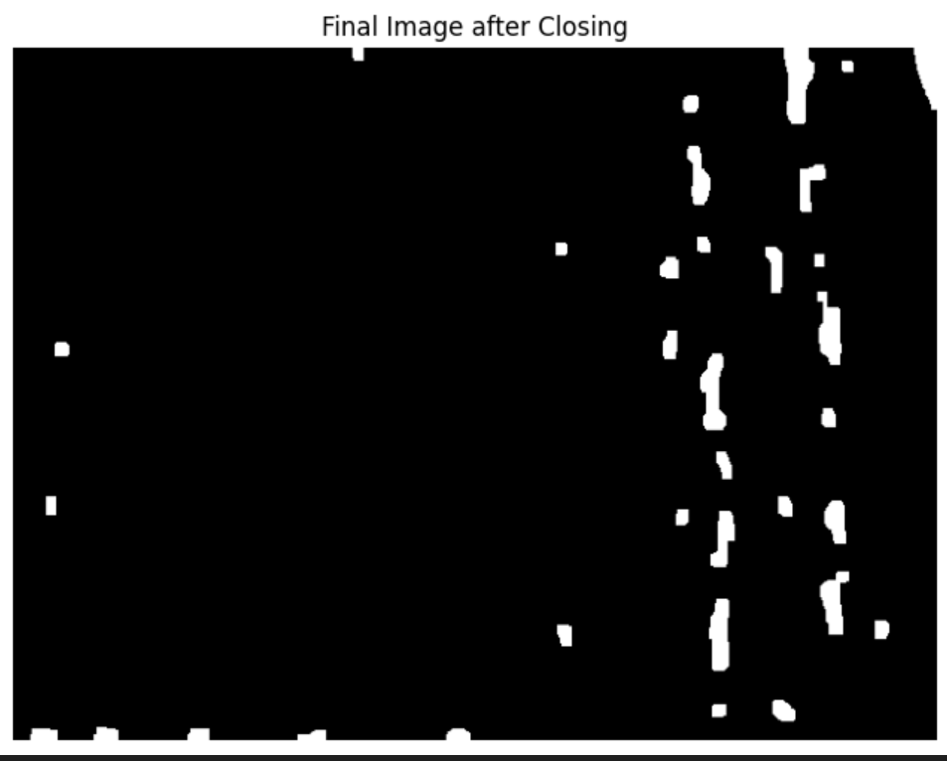

The algorithm works on this image below, we notice that this is probably the next frame of the image, so in principle, this algorithm doesn’t have an issue with this ‘type’ of defect, rather has an issue with the placement of this defect (as we see in the above image that the defect is shown only ‘half’.

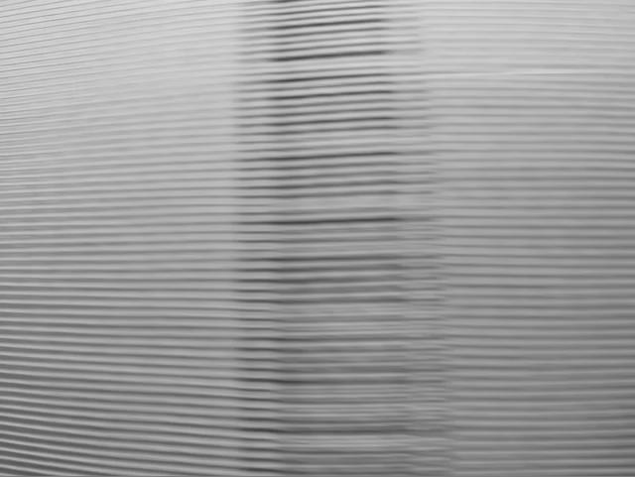

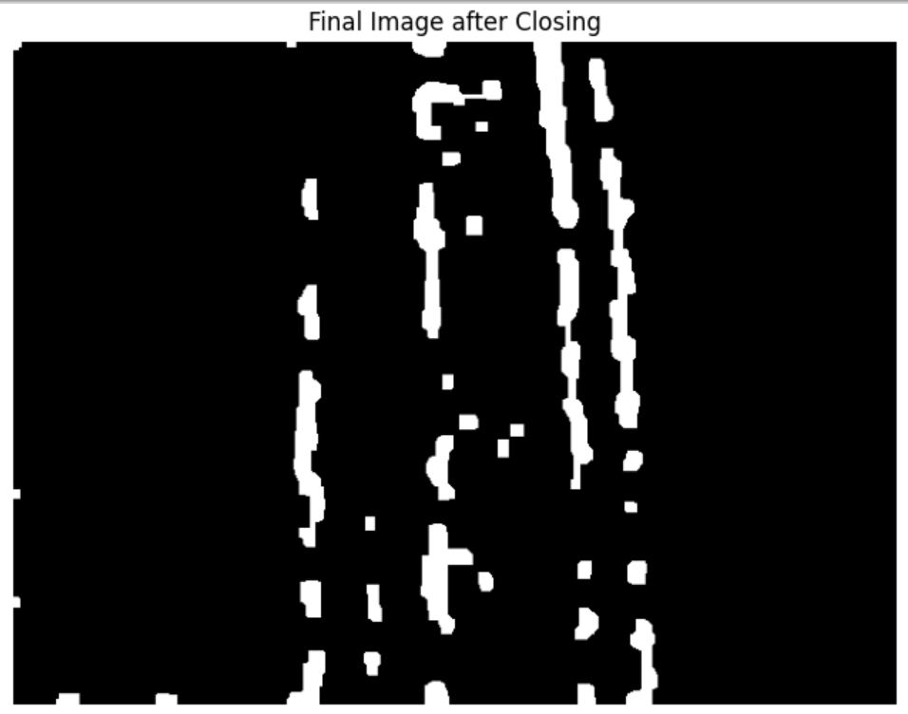

This particular issue is not worrying, because we have been very successful in detecting faults where the placement of the defect was on the edge.

Below are some examples of it:

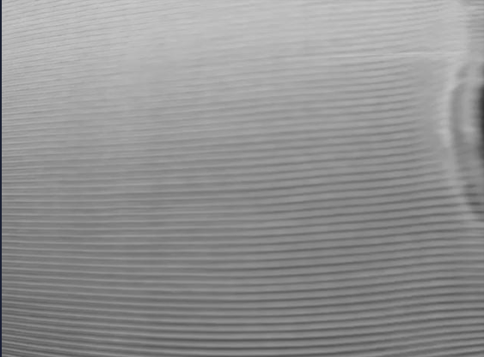

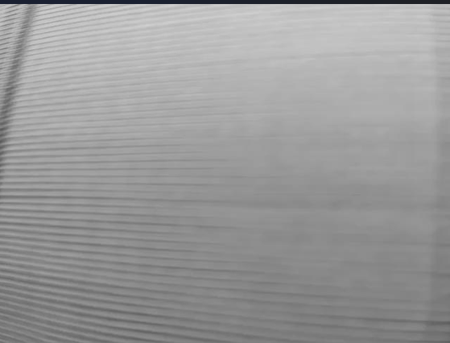

# Some changes in the previous approach:

## Scharr_x + Scharr_y approach

Note, that we are using the exact same process in this approach, it is just that we are adding the y-component to the edge detection as well. It is done to detect bad-defects better, where the entire fault is visible much more directly. Below is the demonstration of the previous process and this added step in the algorithm:

After edge detection (X + Y):

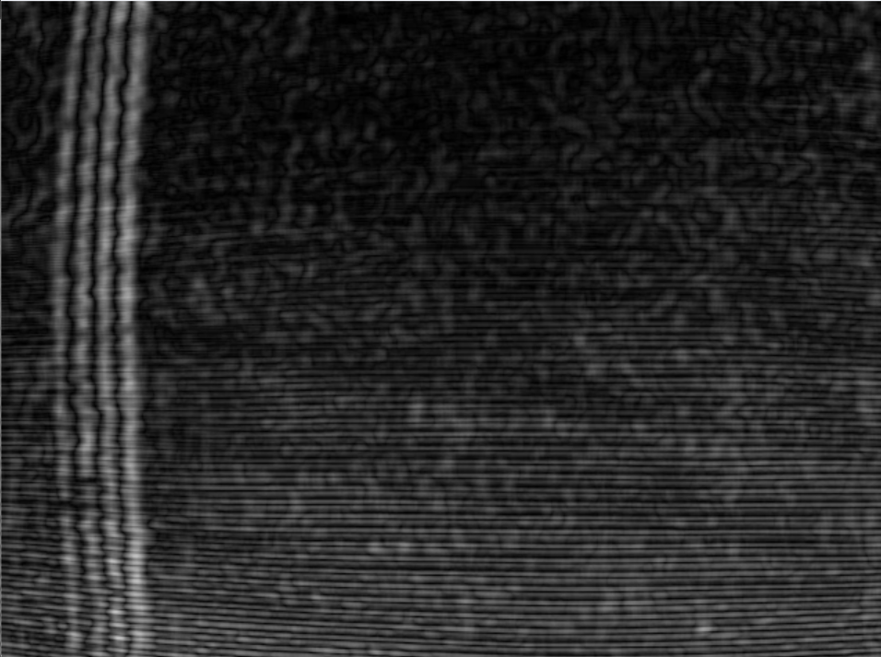

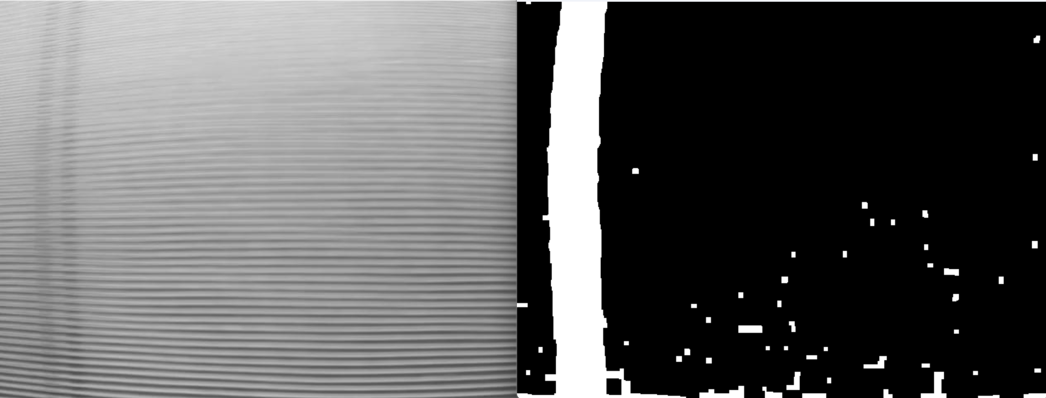

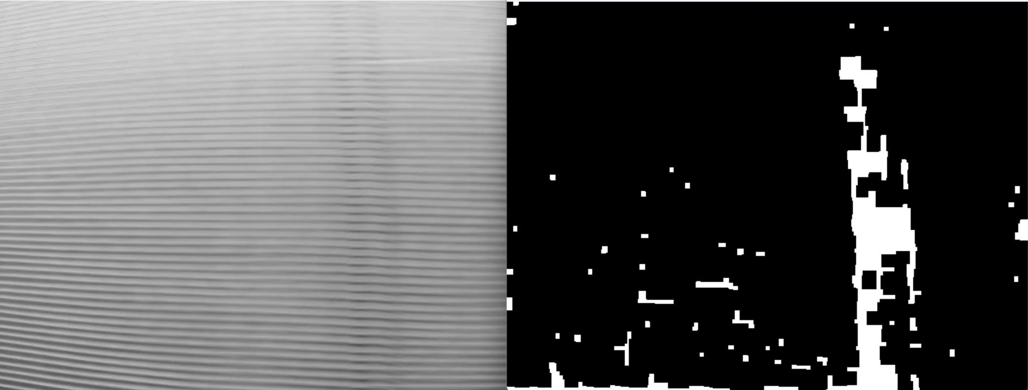



The difference between these two images is very much visible. The arrow depicts what the previous approach of only-x direction was doing to what the added step does to the image.

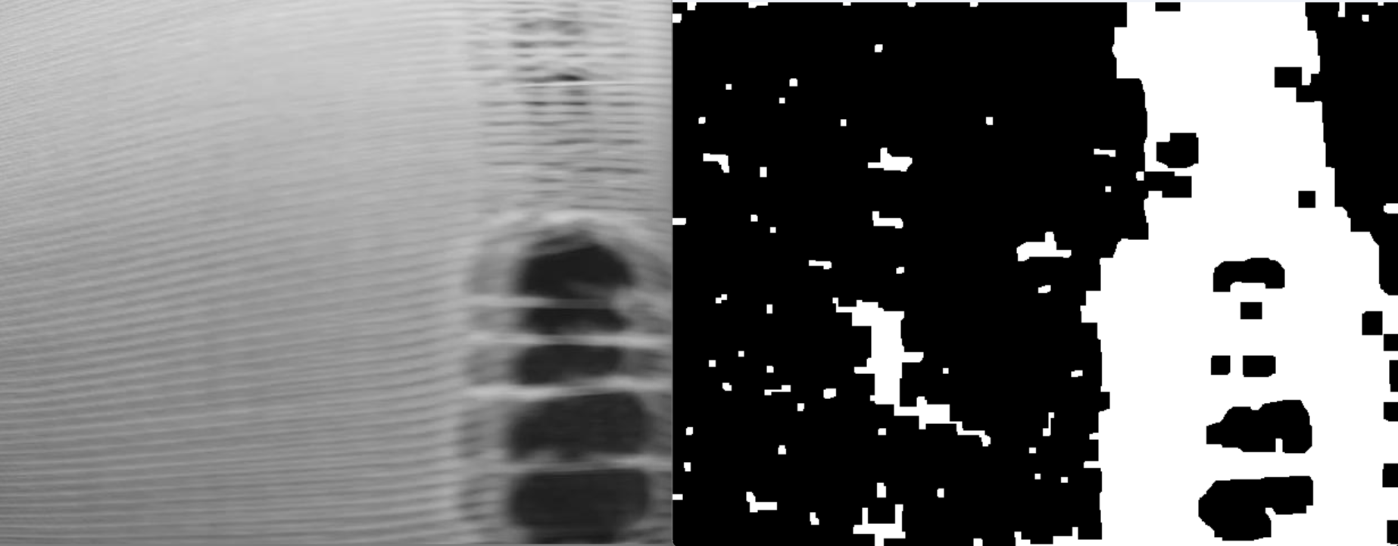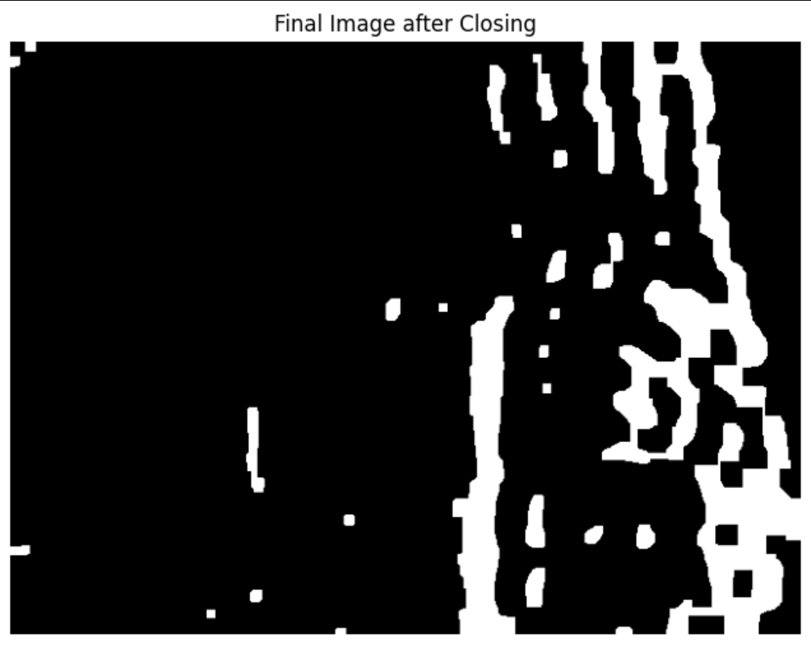

## Using Length + Area of the contour to detect

We use length AND area for the very specific reason shown below.

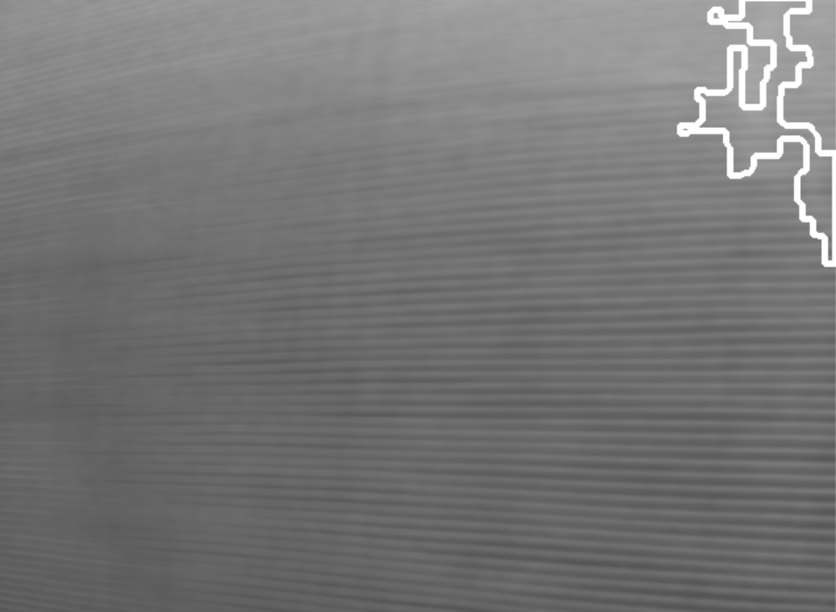928

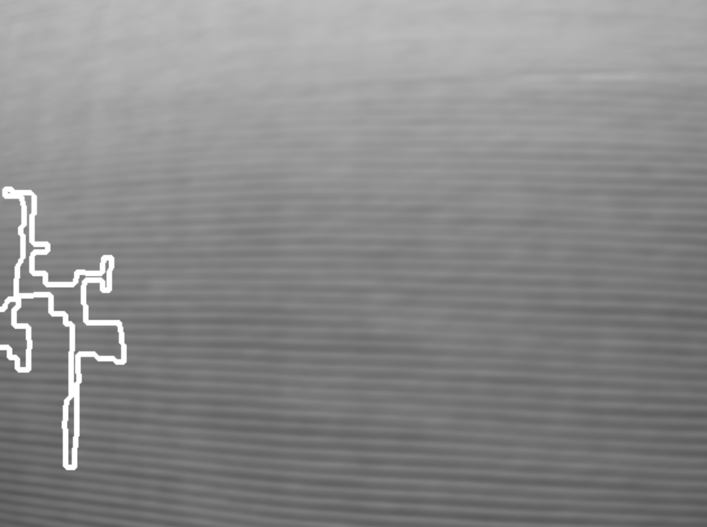1100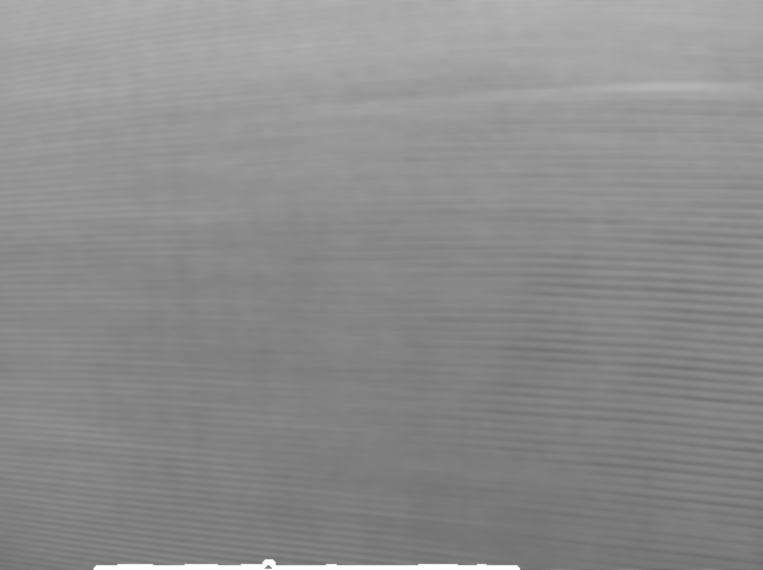

In all the images above, we see that there is a major problem. These images seem to be good-images, but the length of the contours detected seems to be pretty high.

How we get around this is to add a simple layer of if-statement to check the area of this largest contour as well. When we do that, all the above anomalies in the algorithm goes away.

Doing this, makes the algorithm check for both **length and area** of the contour.

## Some example images:

Minor-defaults:

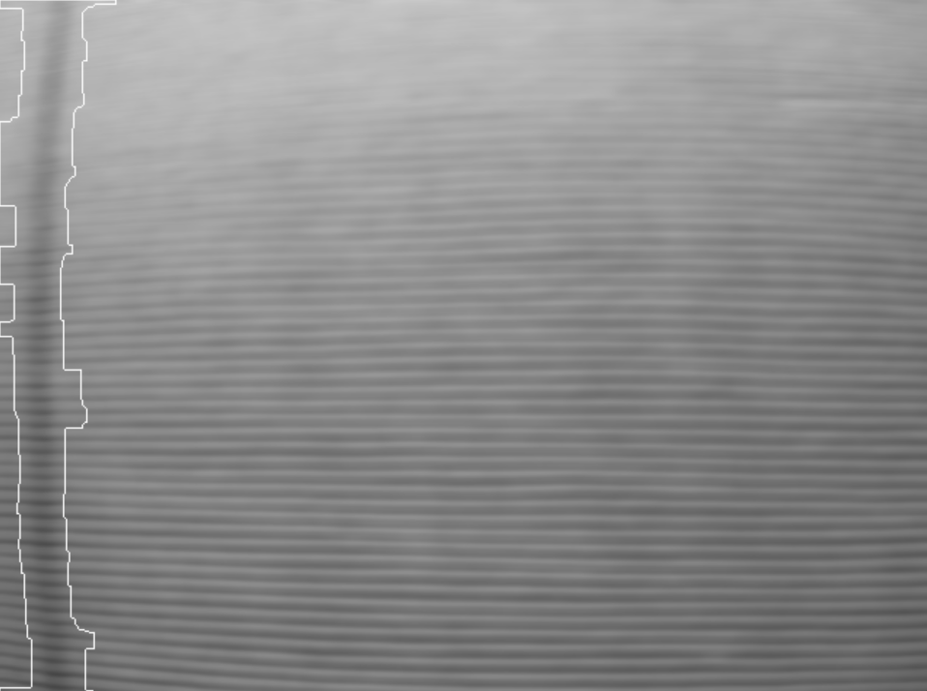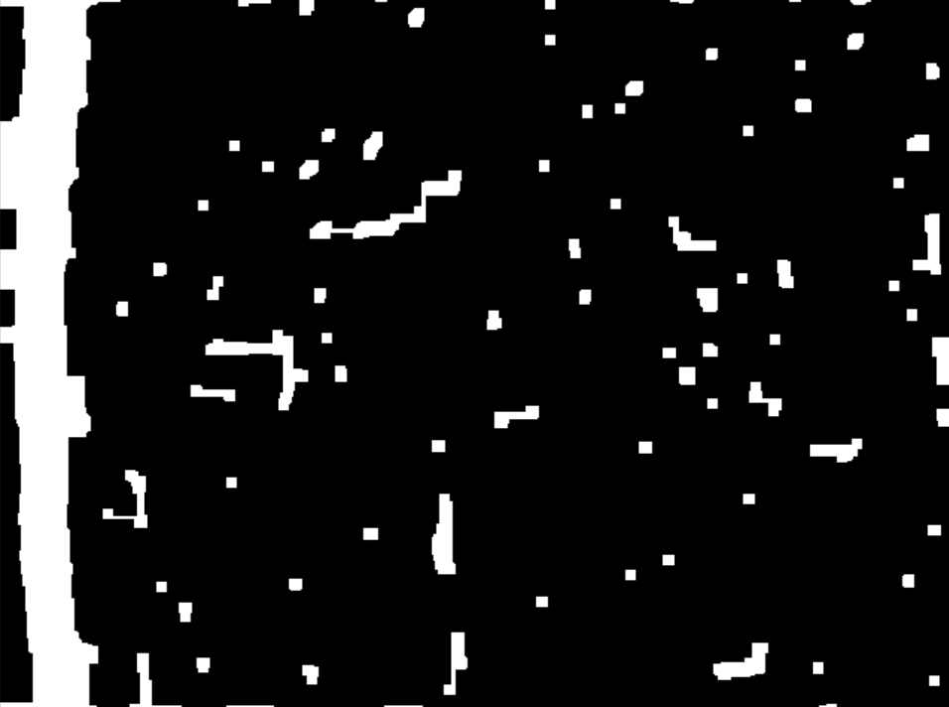

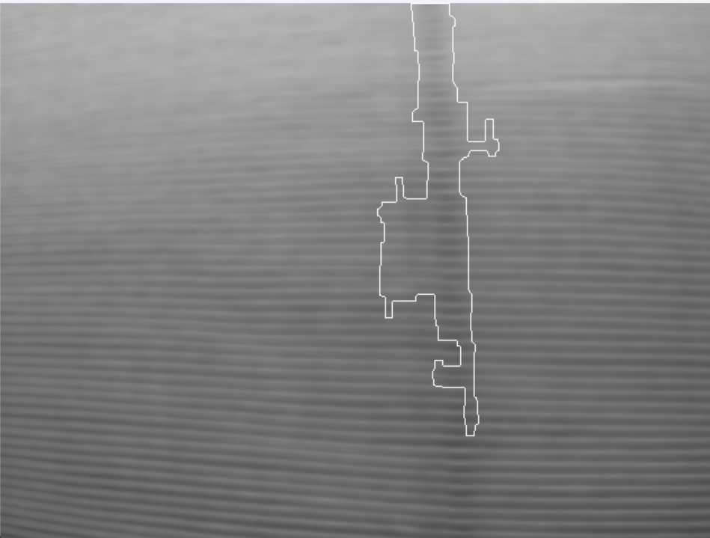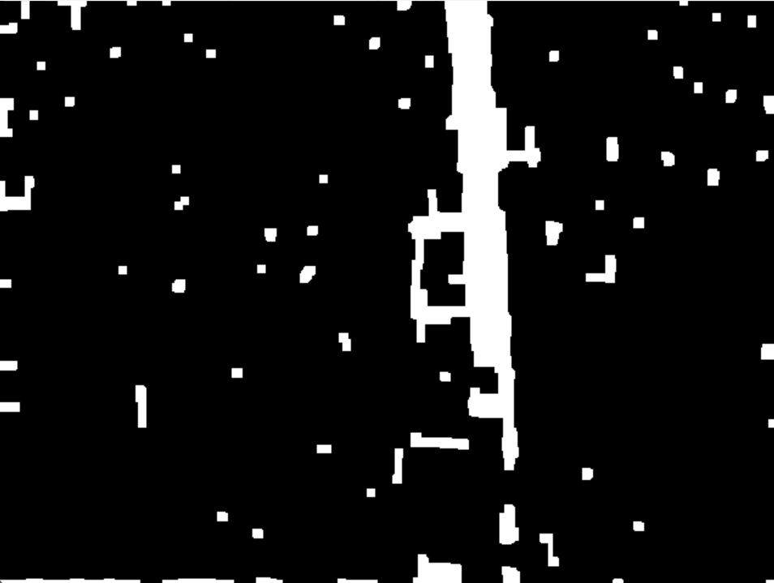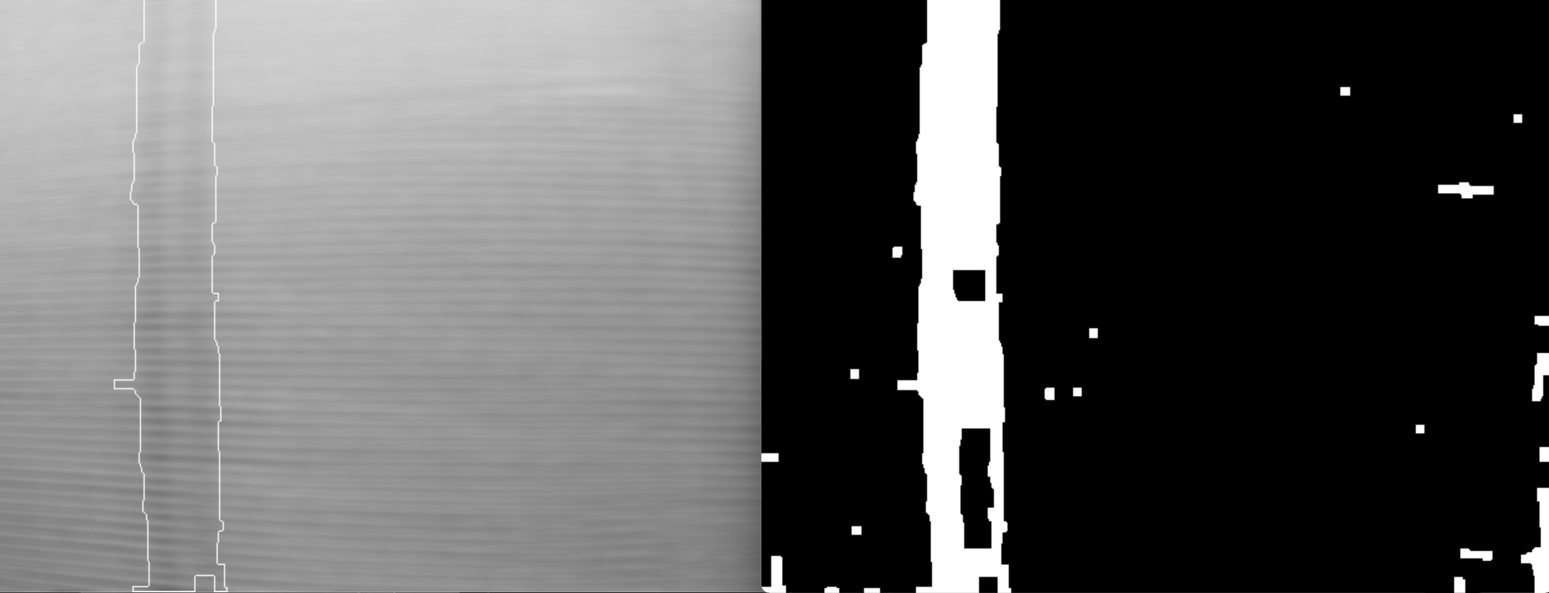

Bad-defaults:

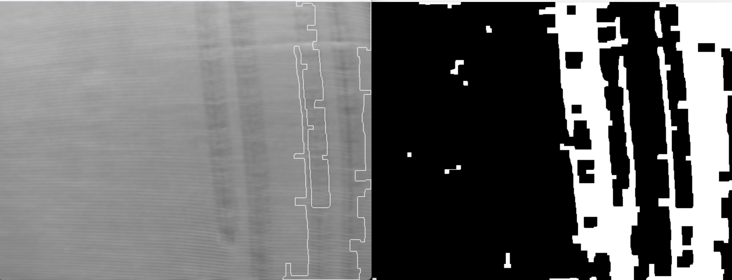

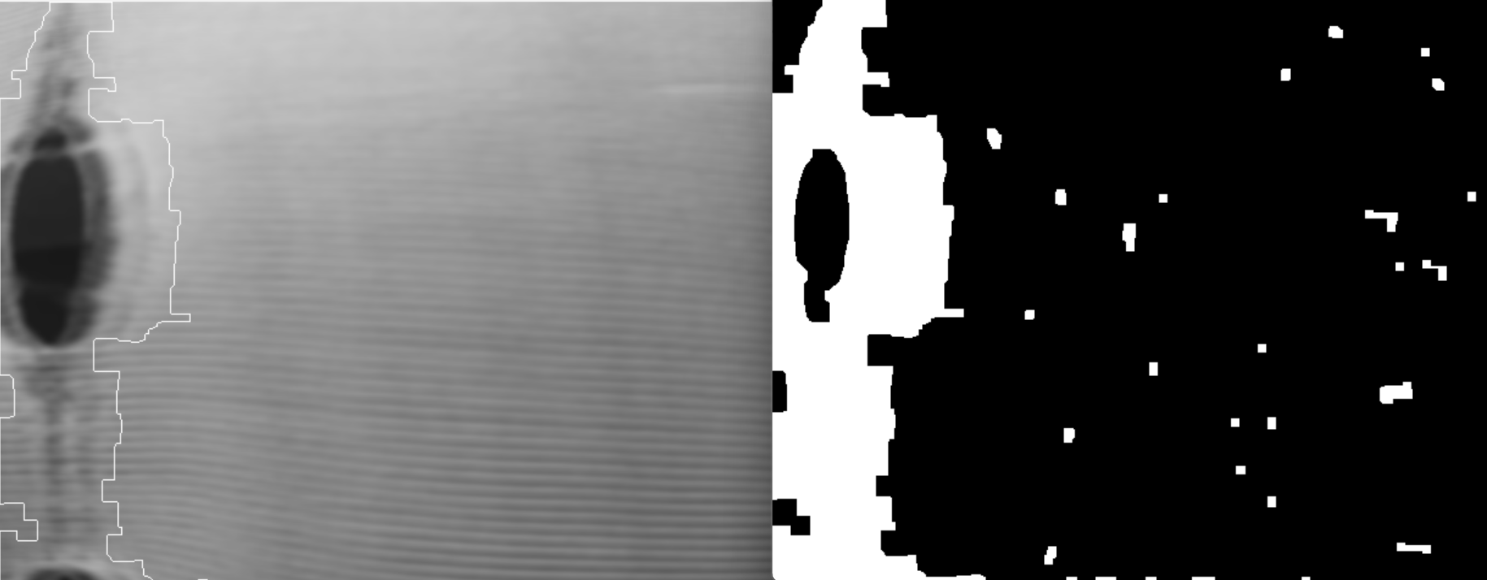s

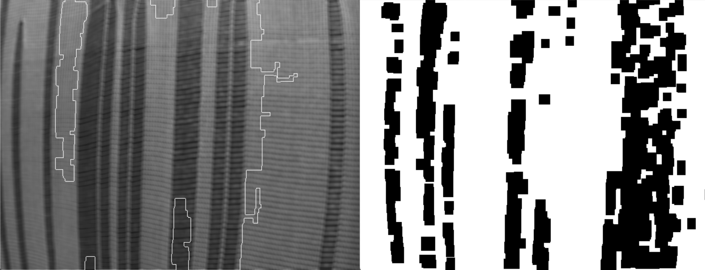

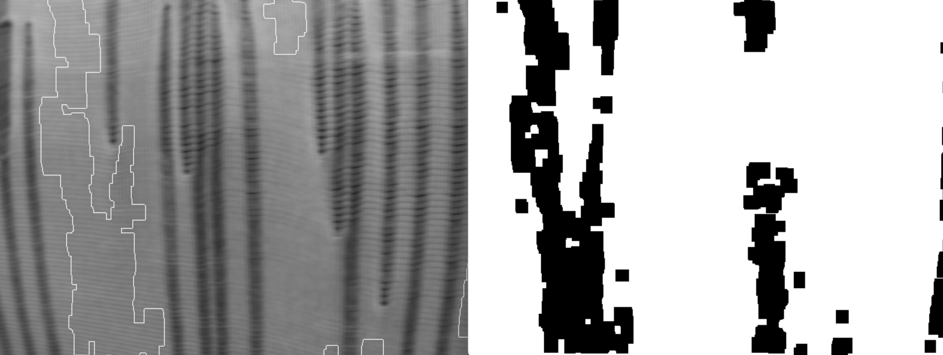

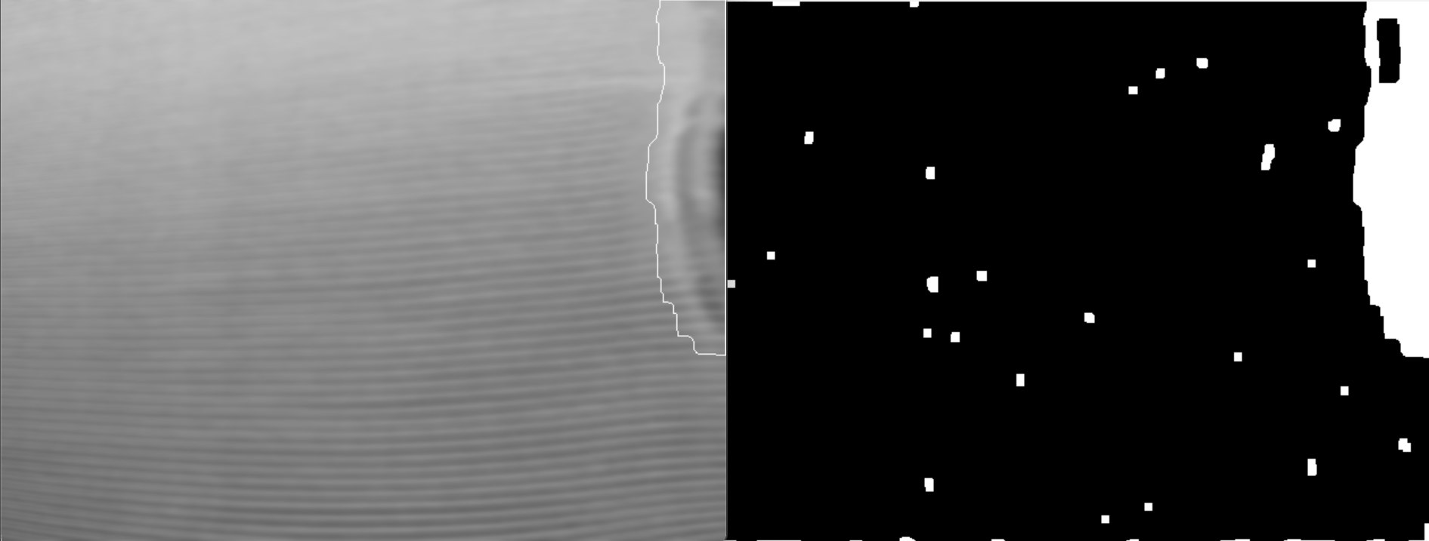

Good images:

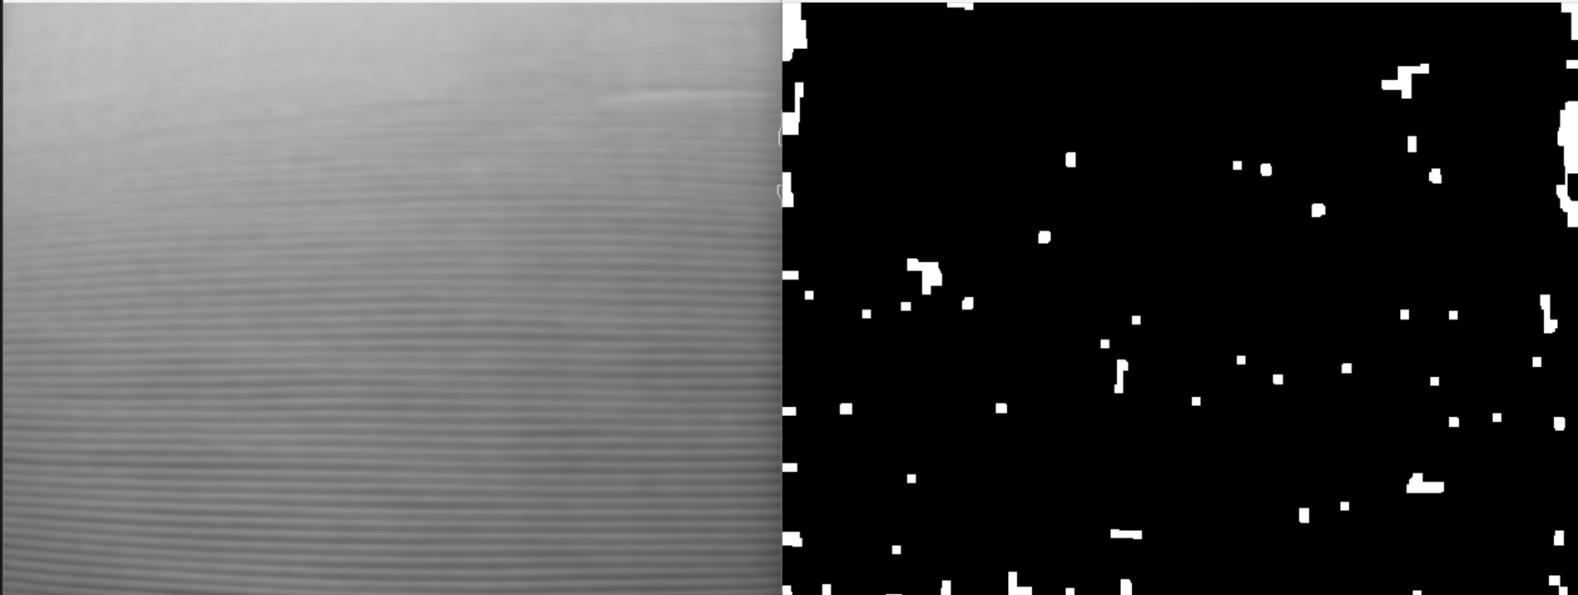

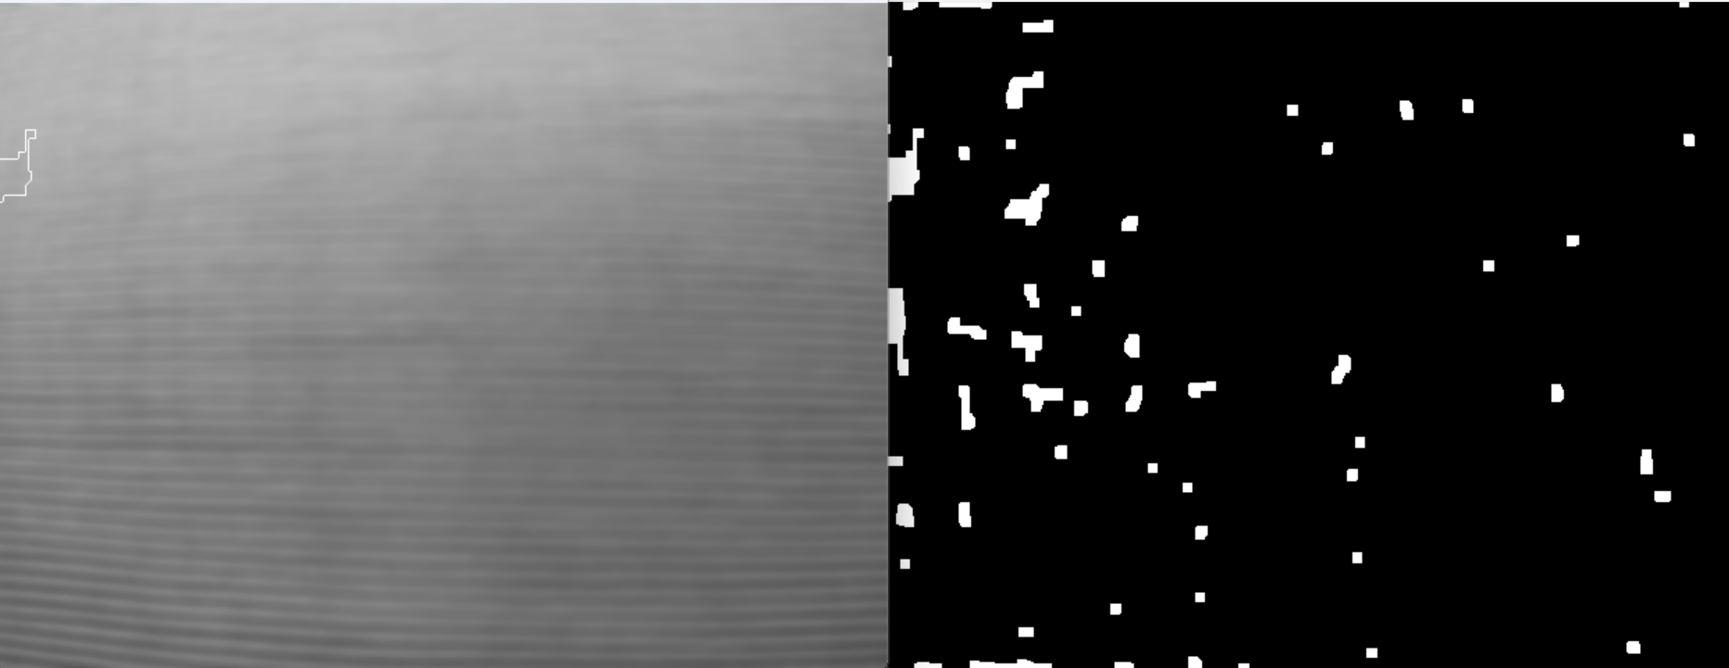

Most good images look like this only.